AFTO Form 781

APPENDIX

APPENDIX: AFTO Form 781

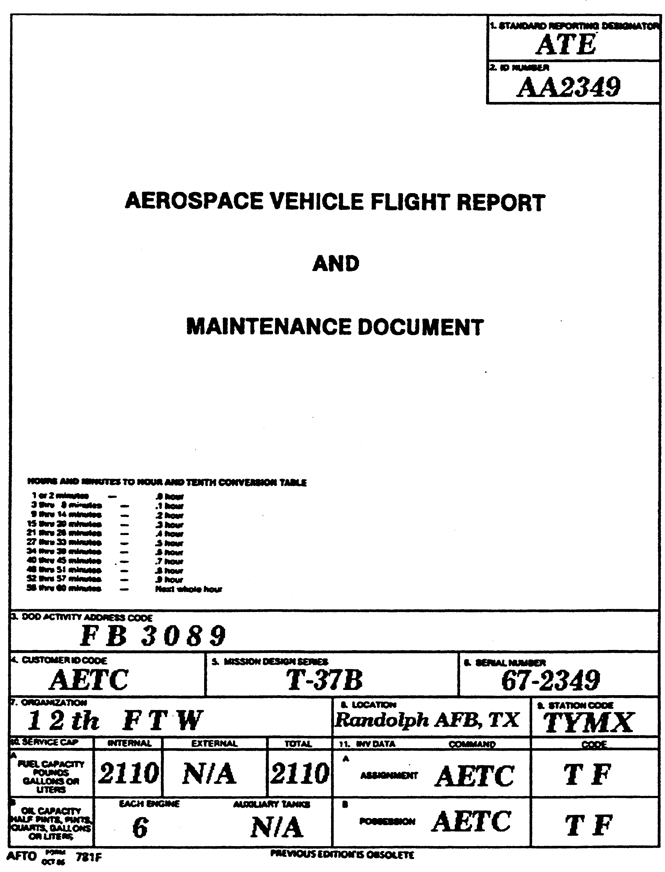
1. Verify that the tail number in the form
matches the aircraft tail number.
2. Ensure that the Government and
Commercial credit cards are in the pocket.

3. Check block 1 for the current date.
4. Block 7: PR Preflight performed by the crew chief prior to the first flight of the day and good for 48 hrs if not flown. BPO is a PR and post flight combined and done at end of the day. Can have either and both have the same validity.
- Block 8: TH thruflight done after each flight if the aircraft will be flown during the day again. 1 entry per flight.
- Block 9: Check aircraft status and Exceptional release. An ER is always required before flight. Indicates person signing ER has reviewed forms and that aircraft is safe for flight. ER good til end of day unless a/c status changes. Then needs a new one.
/ = Minor maintenance. - = Inspection overdue. – worst than /.
X = aircraft is unsafe for flight
- Block 10: Check for discrepancies listed from any previous flight and if they were signed off.
- Block 12: Hours/landings entered for each flight. Memorize this number for later.
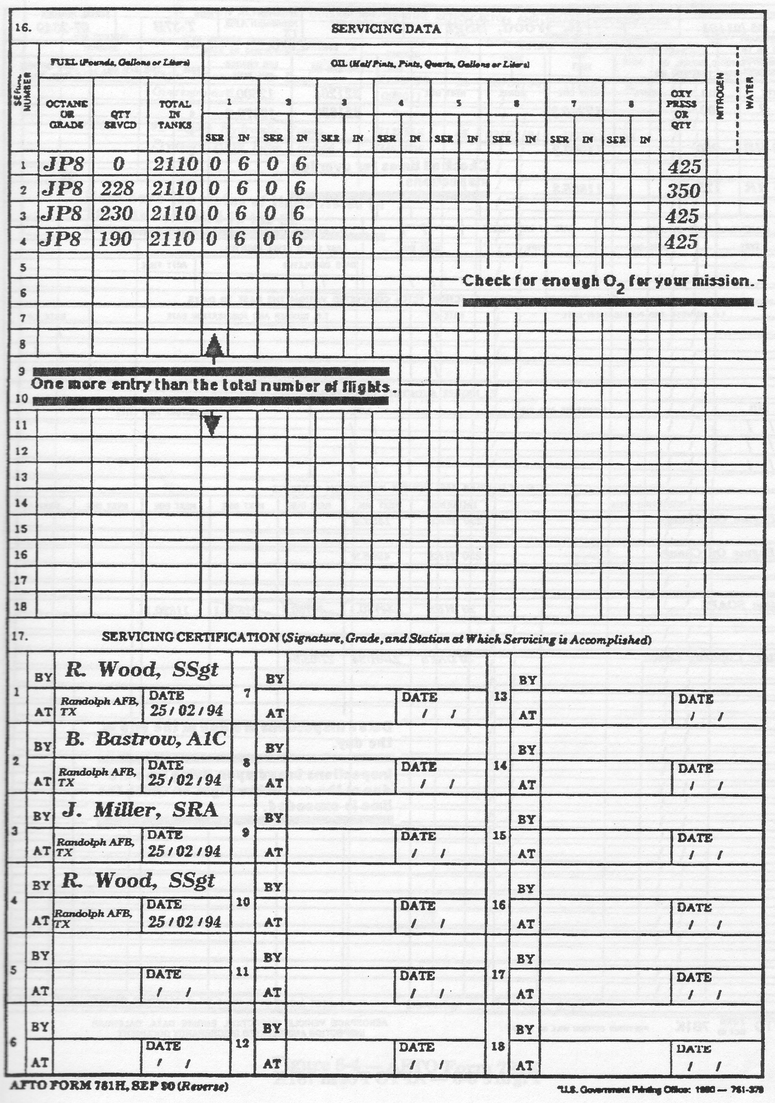

9. Block 16/17 Check for servicing. One more entry than times flown during the day. Check for fuel on board and that servicing was signed off in block 17. The new form in the jet has an entry prior to the 1 line which may be filled at the beggining of the day in a new form. The signature block on the bottom will not be filled in this case.

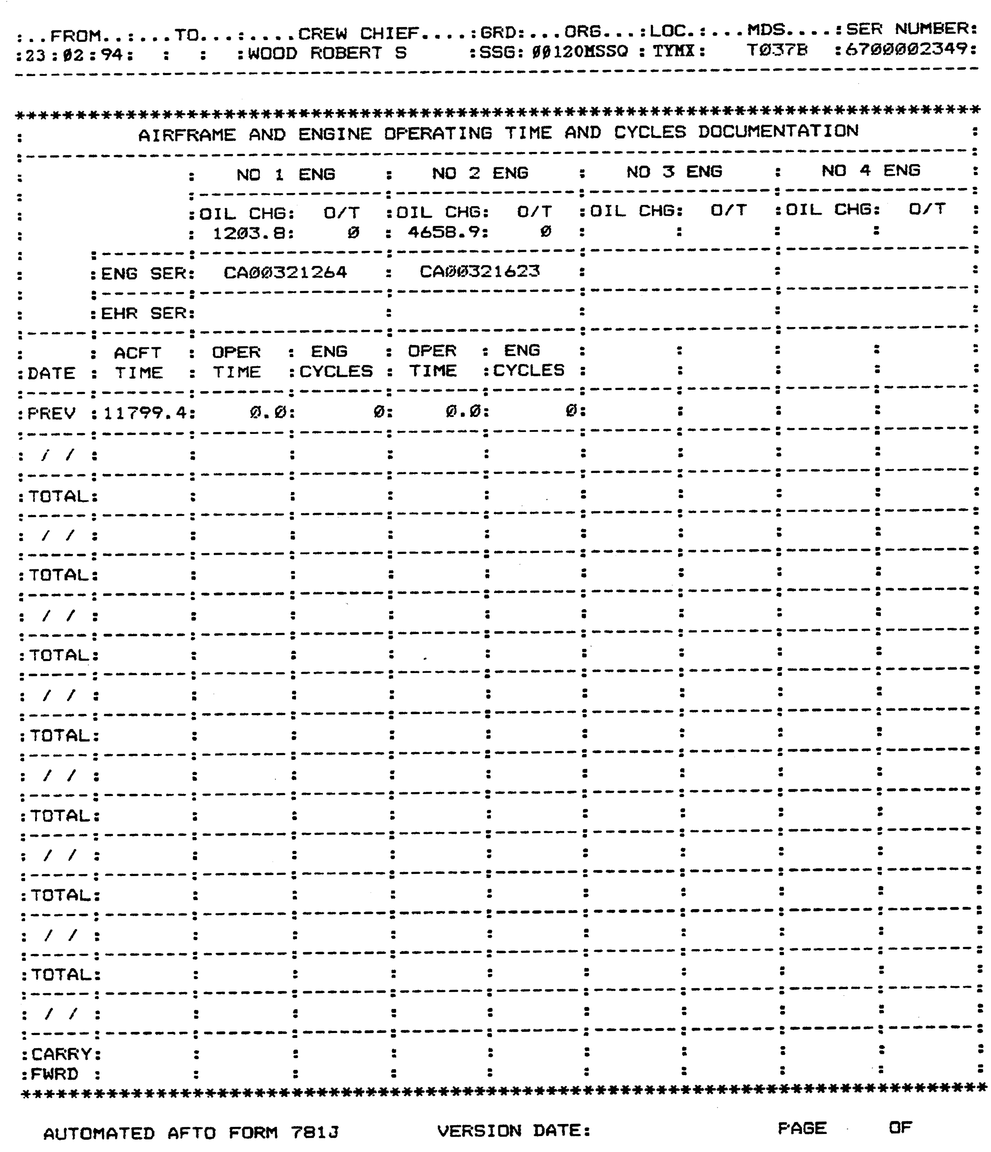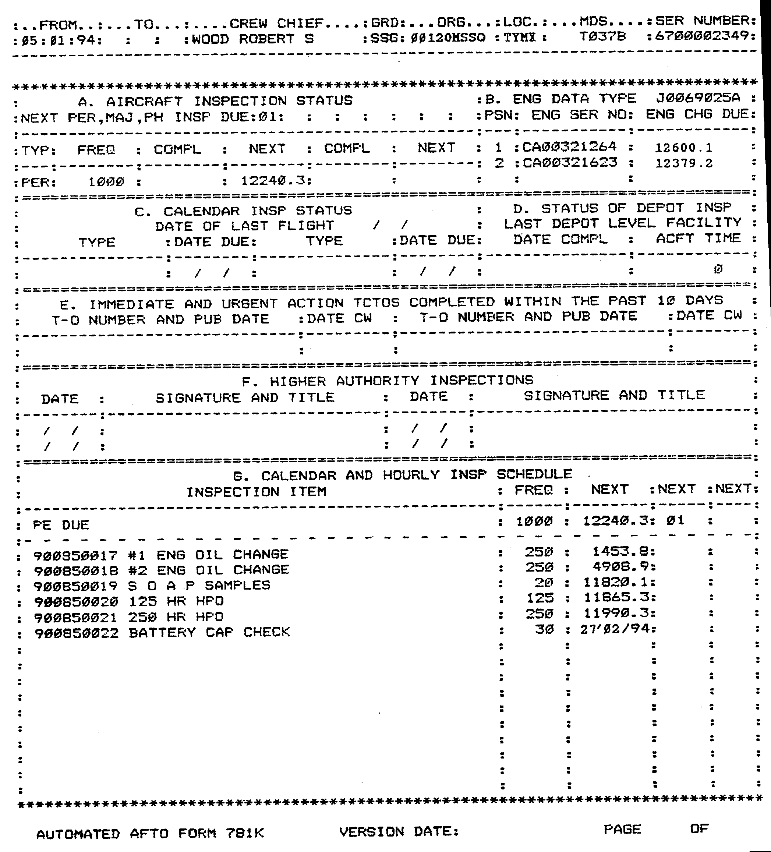
10. Check total time against first page of forms.

- Check Sec A and B for Inspections and engine change times and compare with total time in 781H.
- Check section G for other inspections due.

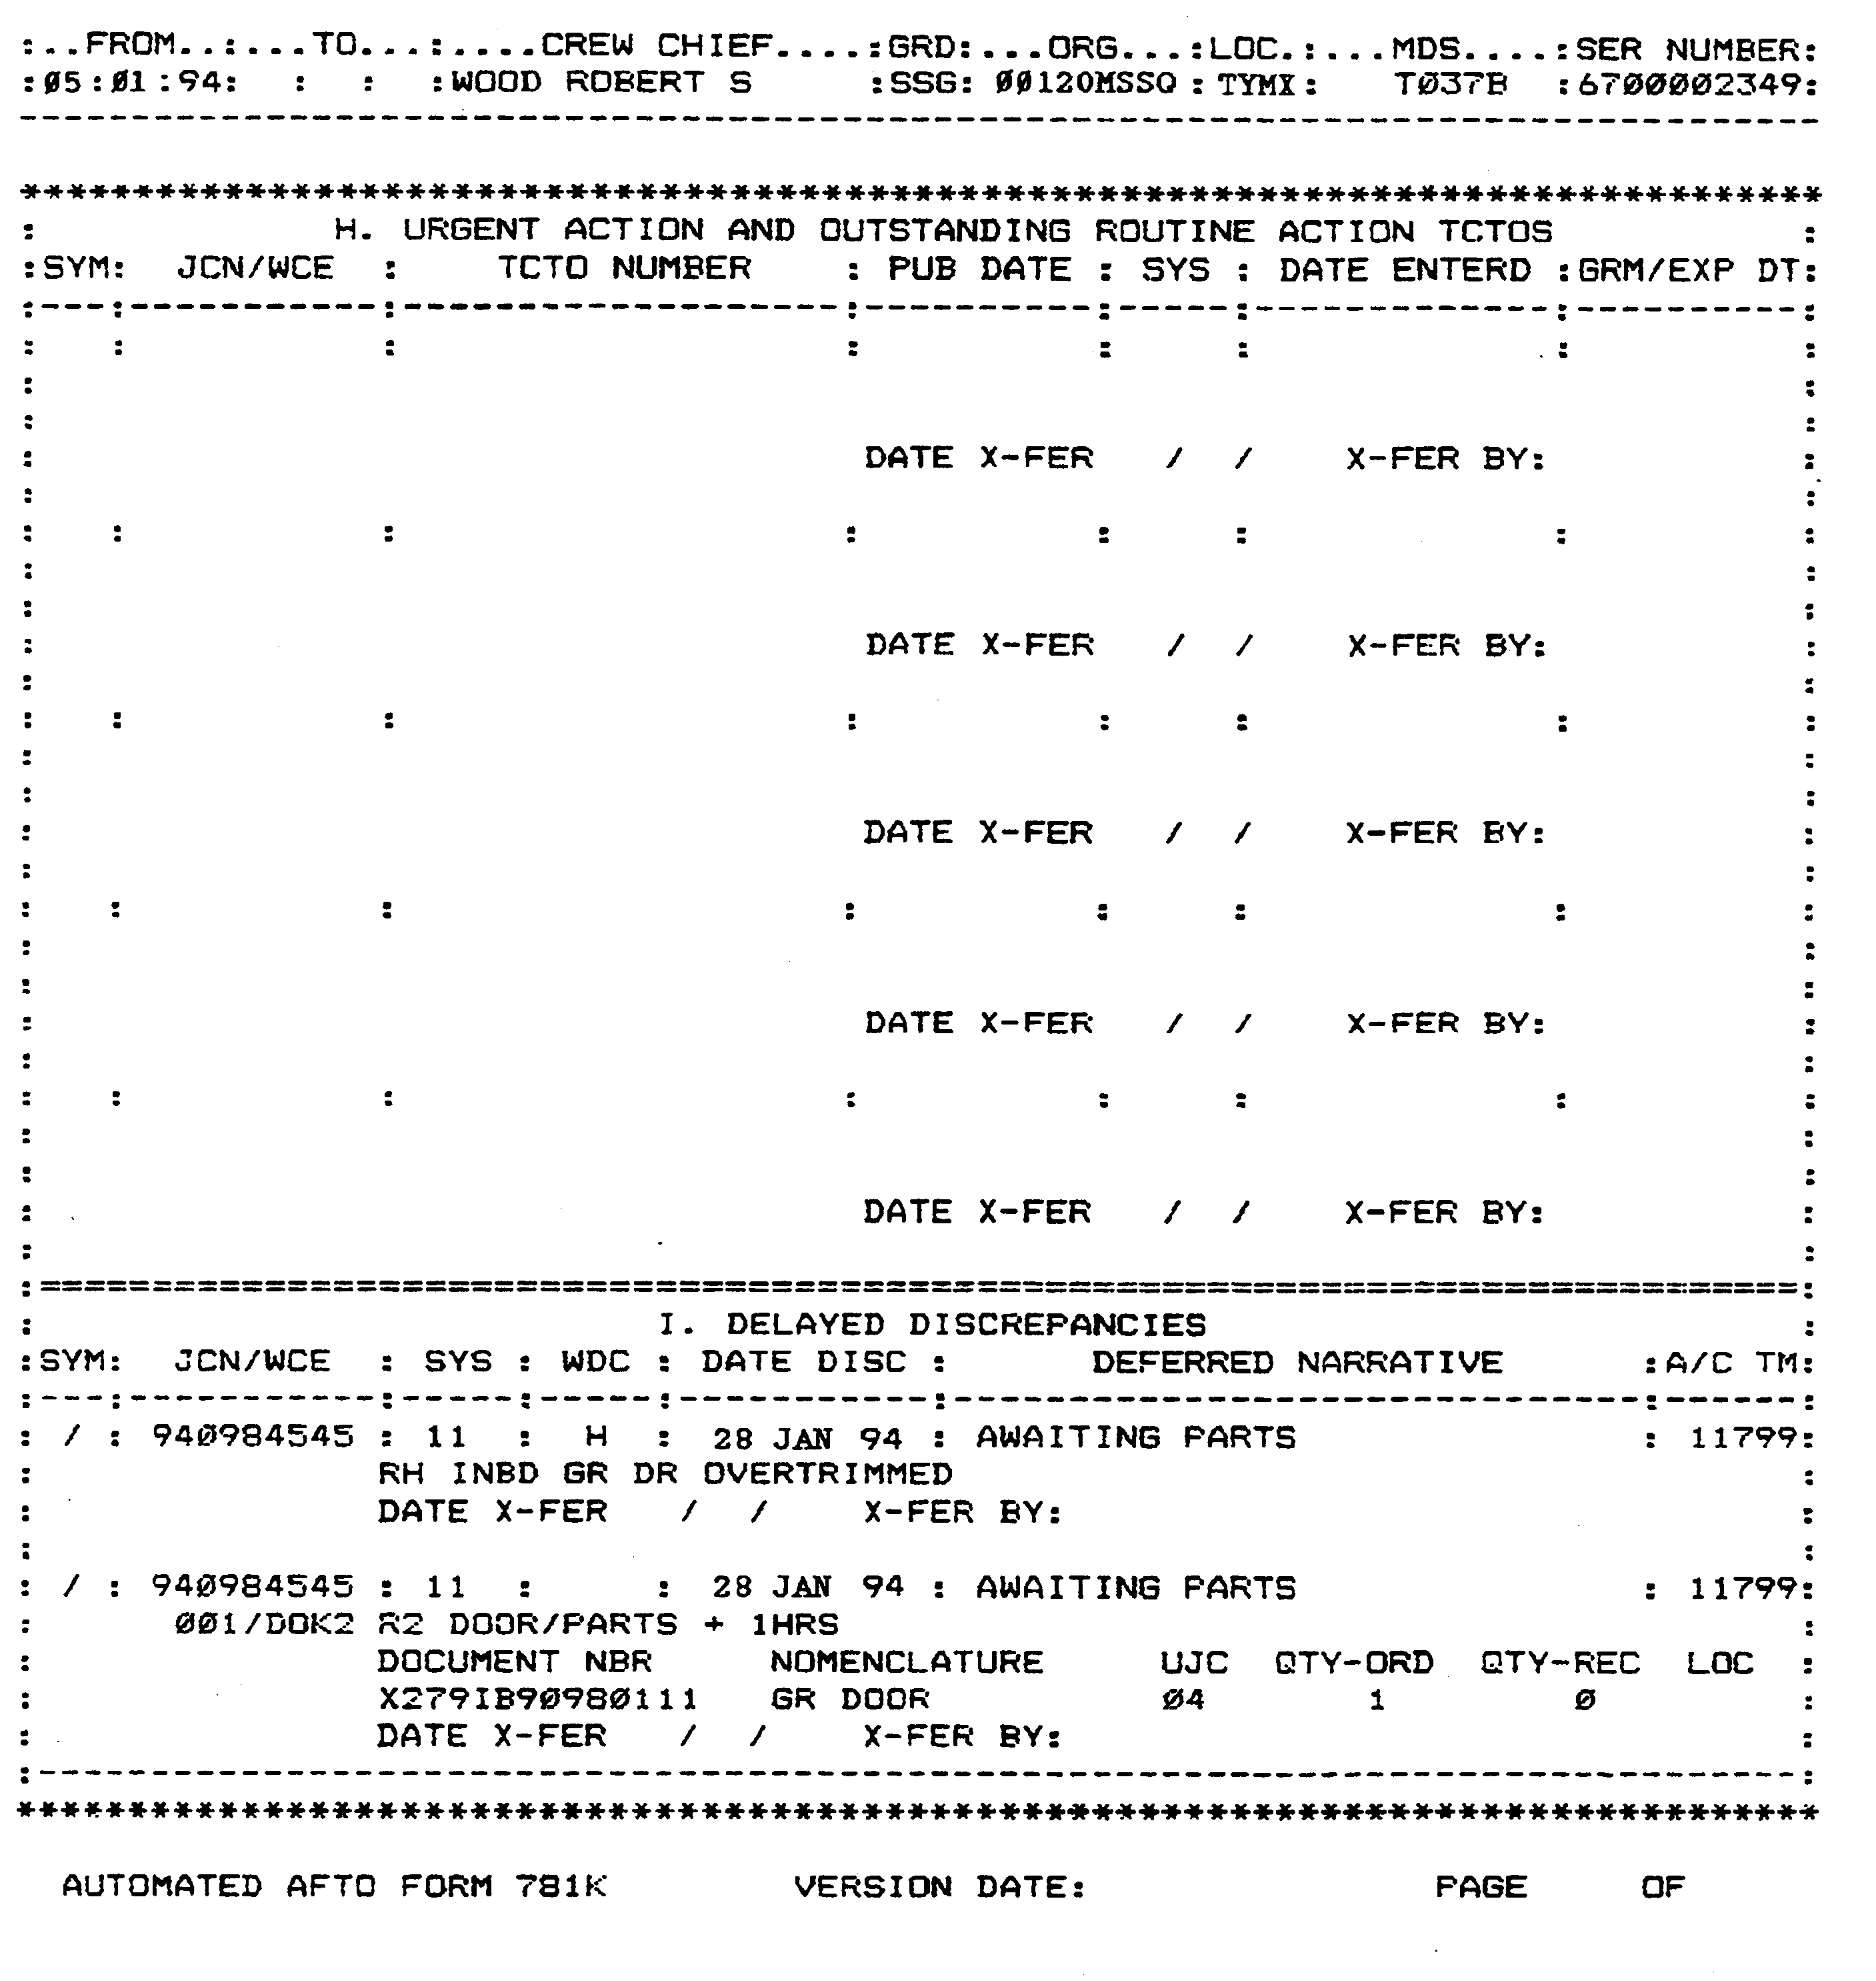
13. Check section H and I for delayed discrepancies and ensure appropriate status is reflected in 781 H. Worst status should show.

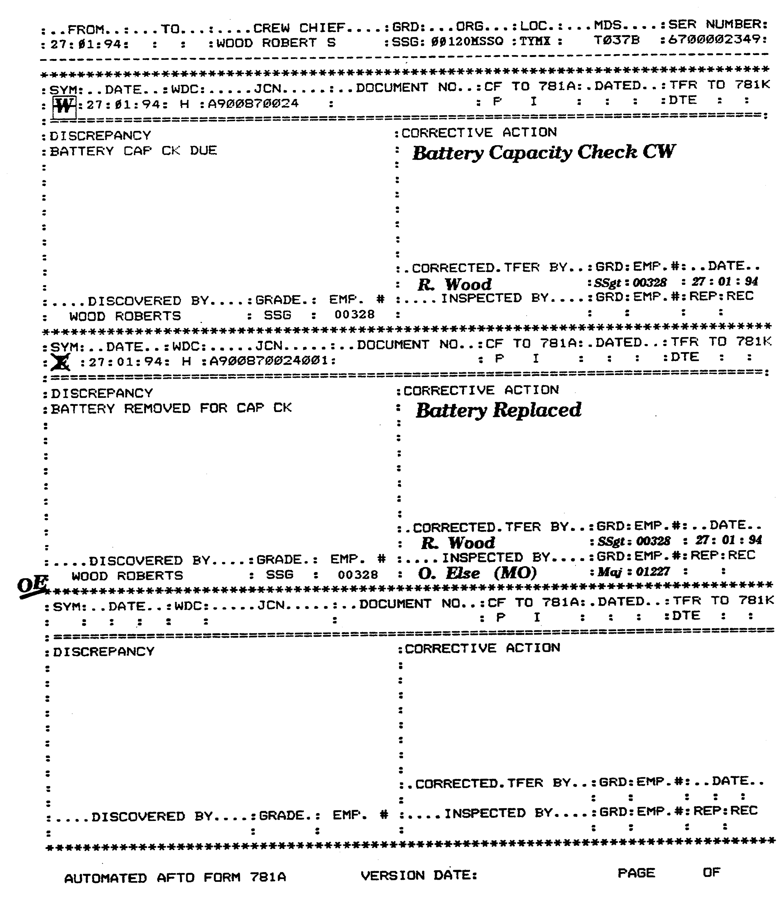
14. Ensure uncorrected discrepancies are reflected correctly in status box 781H.

15. Check ER. Look for red line of the individual who signed ER and his initials after the last write up. If there are write ups past that line then need new ER

16. A red X must be also inspected.

17. Check for tire pressure checks.

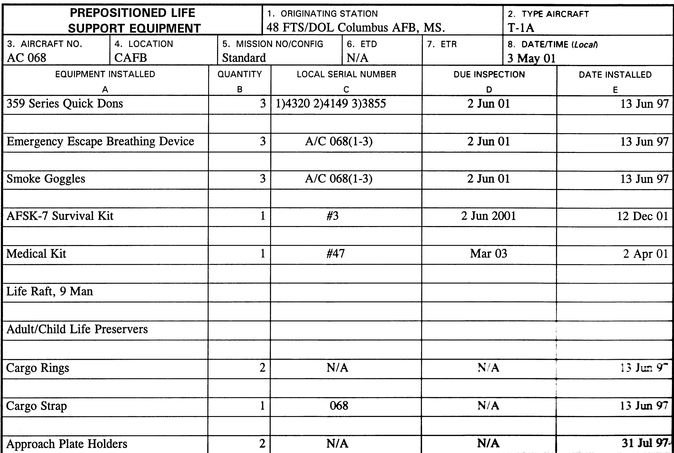

18. Review Life support equipment inspection dates. Look for overdue inspections.

19. Sign off Life support equipment inventory.



